MGT 656 - Class Project

Software Development Project Status Report

Project Final Report

Professor Kyle Jensen



Team: Morning-Leaf

Members:

Raúl Madriz raul.madriz@yale.edu

Ernesto Reyes ernesto.reyes@yale.edu

Ernesto Castillo ernesto.castillo@yale.edu

Carlos Romo carlos.romo@yale.edu

December 11, 2015

**Final Project Report**

Heroku application address: (<http://mgt656-morning-leaf.herokuapp.com/>)

Version control: (<https://github.com/Morning-Leaf/morning-leaf-reporting>)

**Burndown Chart**

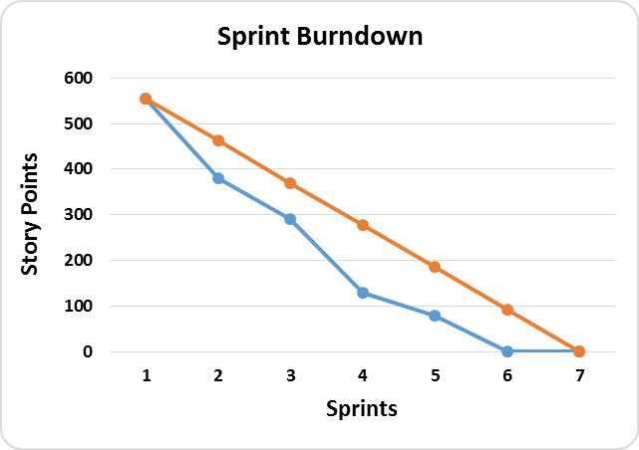

**Labels**

**Ideal Burndown**

**Actual Burndown**

**Sprint Completed Stories**

1. Analyze traffic data to our site (This due to the fact that we have just finished the tasks for this user story)
2. Extras that the site might need

During this last iteration the team was very well organized, because we already knew the activities that we were going to work and develop for the final sprint. As a general comment we think that the project has being very interesting and it has had difficult points for all the team members. But a very important thing that has helped us a lot to minimize difficulties is our weekly meeting that we had every Thursday. During this meeting the team had the time to discuss and address important issues that we encountered in some tasks that were developed of the user stories that we created for our project. In general we can definitely affirm that team meetings are a key part for every project in a scrum environment. During our last meeting we discuss the finals activities that had to be developed for the project. We didn’t had any big issue with the activities that were developed and concluded. The only issue that we found was that in the test even though they have been updated to new versions, they have some issues detecting html tags such as the header tag. So we found a workaround to make the test pass. We moved the HTML header tag outside the original header nunjucks tags.

During the last iteration we had already concluded all our user stories and we focus on the traffic data analysis of our application. Analyzing our burndown chart we observe that we were able to finish all tasks before the final sprint. This was very helpful for the team, because we were able to revise important issues of our application. From the 555 story points that we reestimated for the 7 sprints of the final project, we have completed the 555 story points which is traduce into a concluded good job that the team was able to fulfill. We were able to manage more than 93 story points per sprint that would have been the ideal burndown chart. The estimations that we did since the beginning were very accurate with what we expected and we just reestimated our burndown chart one time. We used waffle to distribute the activities and also we had google docs so that all the team members can be informed of the tasks they had to deliver. But as we mention above the most important to fulfill this project was the team meetings that we had every week.

**Sprint Backlog**

During the last iteration we were able to manage and finished all the tasks that we had planned for this last iteration that were to analyze traffic data to our site and to add extras to our site that it may need.

**Traffic Data Analysis**

For the A/B testing of the Make Donation experiment there were a total of 45 experiment sessions from December 7 to December 10. The traffic was divided as follow:

* 44.44% of the traffic got there but did not interact.
* 33.33% of the traffic did donations.
* 22.22% of the traffic asked for support.

For the A/B testing of the Add RSVP Text to Events experiment there were a total of 1,596 experiment sessions from November 29 to December 10. The traffic was divided as follow:

* 44.17% of the traffic got there but did not interact.
* 55.83% of the traffic RSVP.

**Product Backlog**

During our last iteration we had already finish all the user stories that we had been asked to do and the reestimated issues that were important to have in our application like the google analytics issue that stakeholders wanted. For this specific sprint we didn’t had any task or user story to develop. We only analyzed the traffic data coming to our site and we add some extras to our application that we thought it needed. In the next chart we show all the user stories that were developed during the 7 sprints of the project.

**What Morning-Leaf Developed**

**Beginning**

At the beginning we had specific instructions of what to develop from our stakeholders. Our main goal was to deliver an application that allows users to create and RSVP for upcoming events. During each sprint our application improved and until sprint 5 it looked like the following figures.

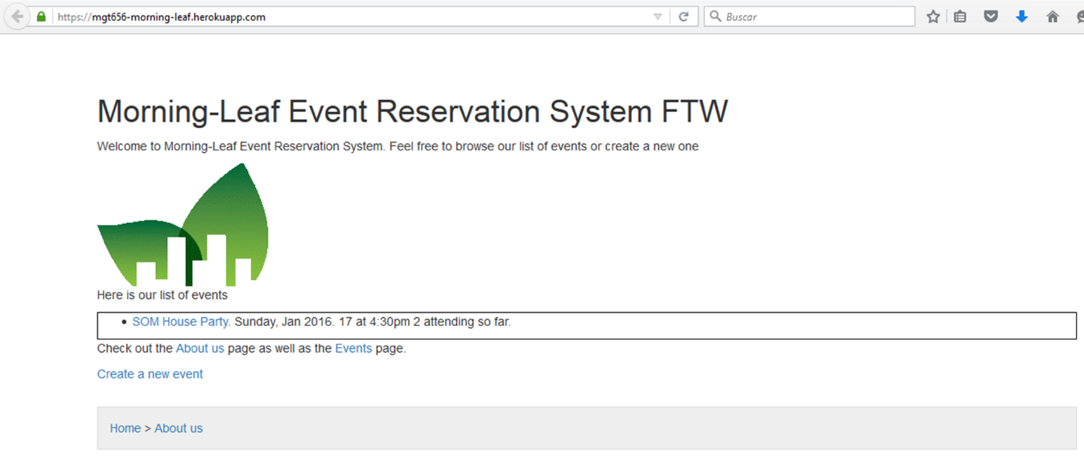

***Figure 1***

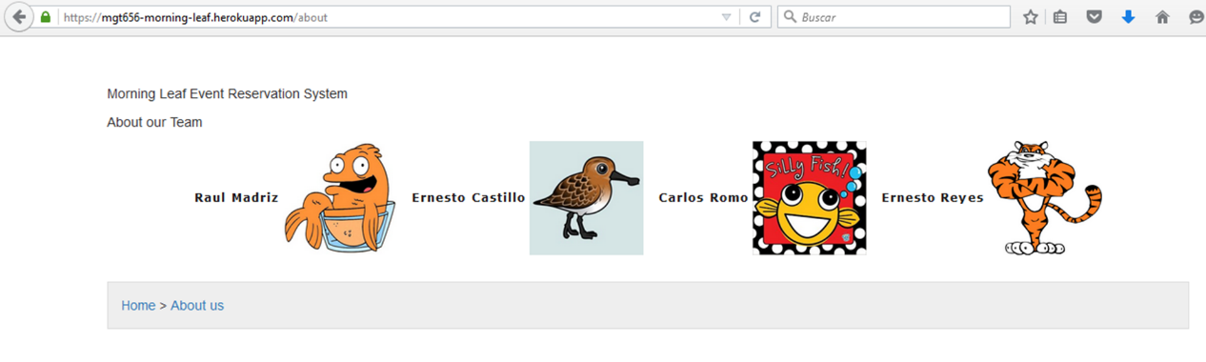

***Figure 2***

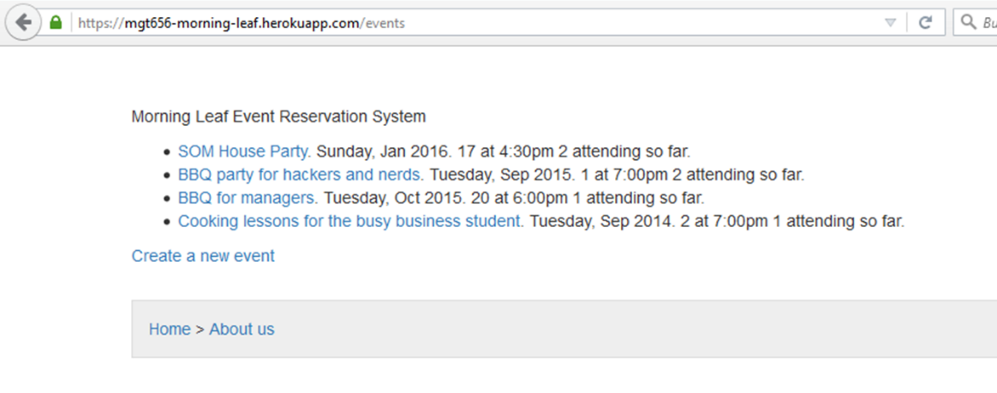

***Figure 3***

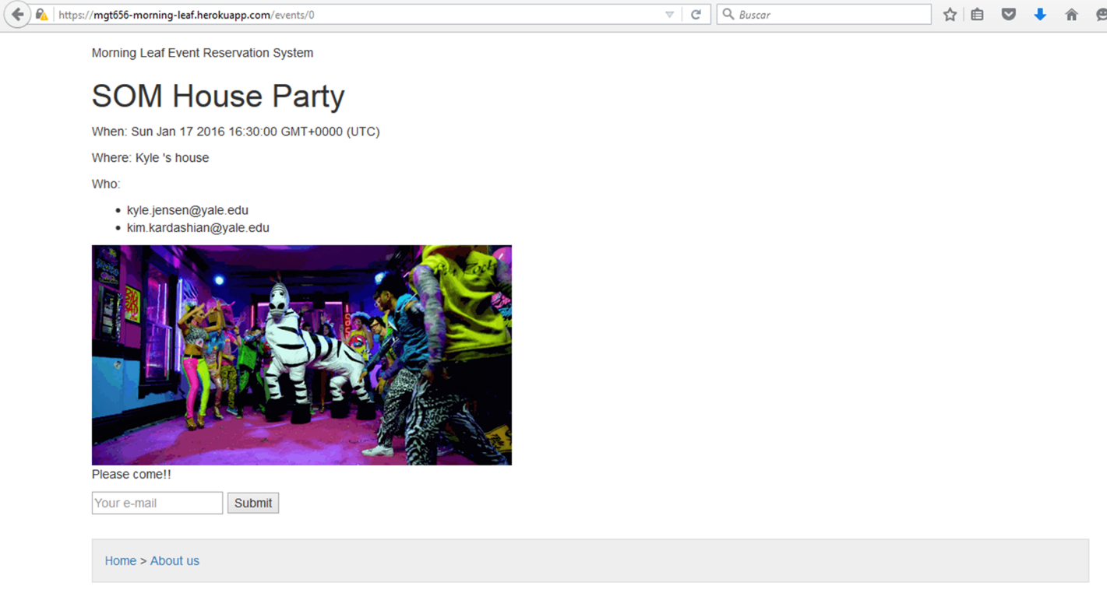

***Figure 4***

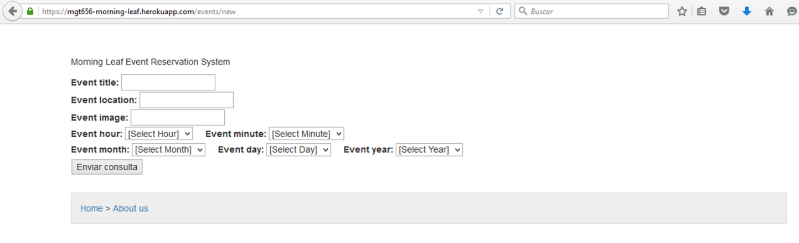

***Figure 5***

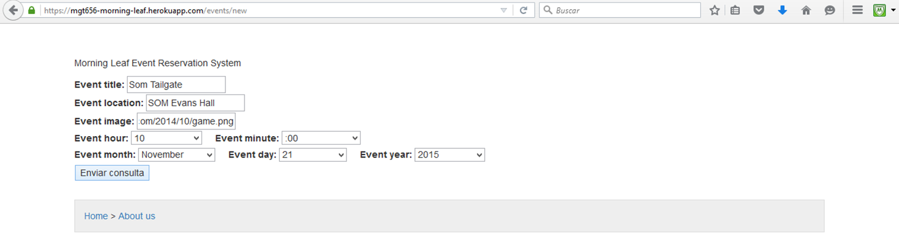

***Figure 6***

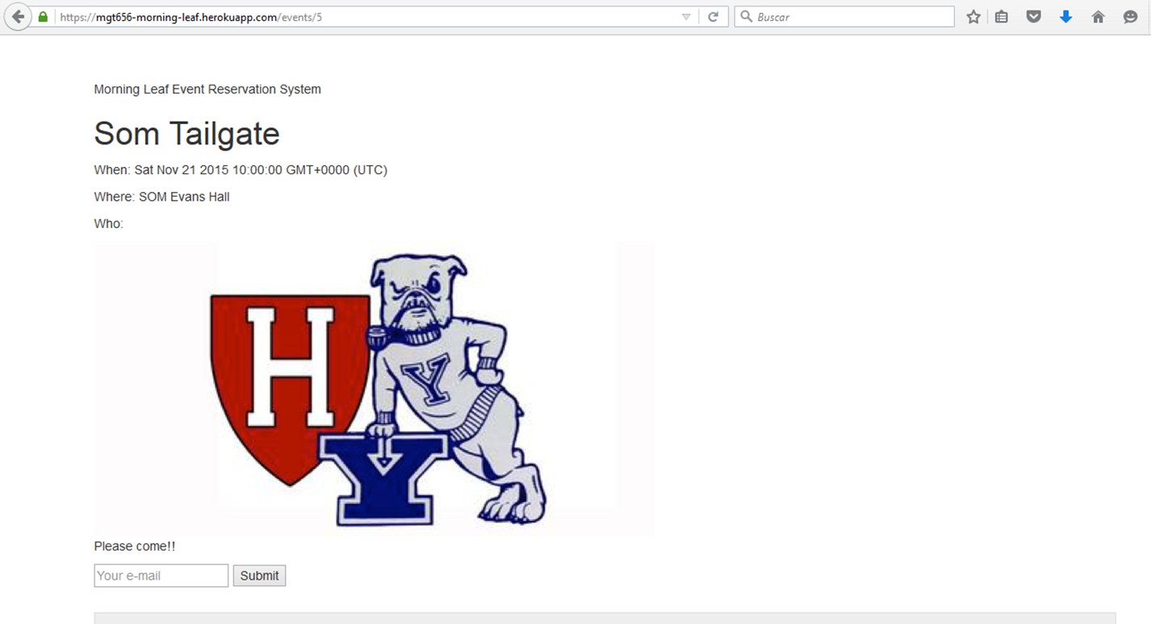

***Figure 7***

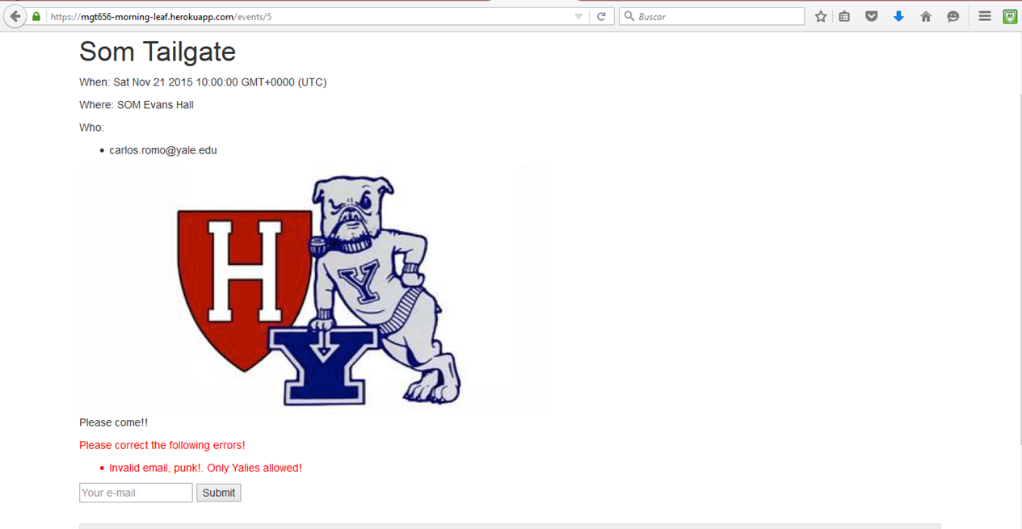

***Figure 8***

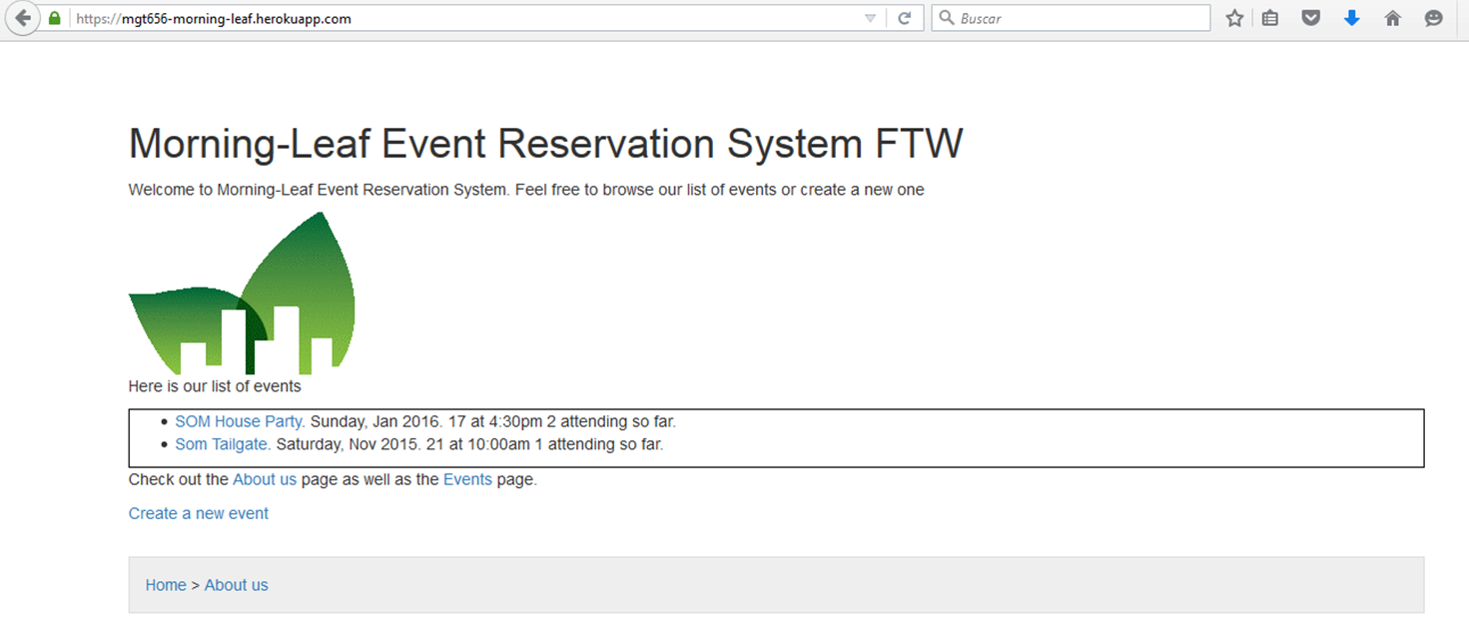

***Figure 9***

During sprint 6 our application was improved and changed. We add a different layout to make it more friendly and likeable for customers as our stakeholders demanded us. We also changed the name of the application to CLUBHERO to have a better and more fresh name. We also include the code of google analytics. This because our stakeholders wanted to see specific information of the traffic that our new application had about support or donate.



***Figure 10***

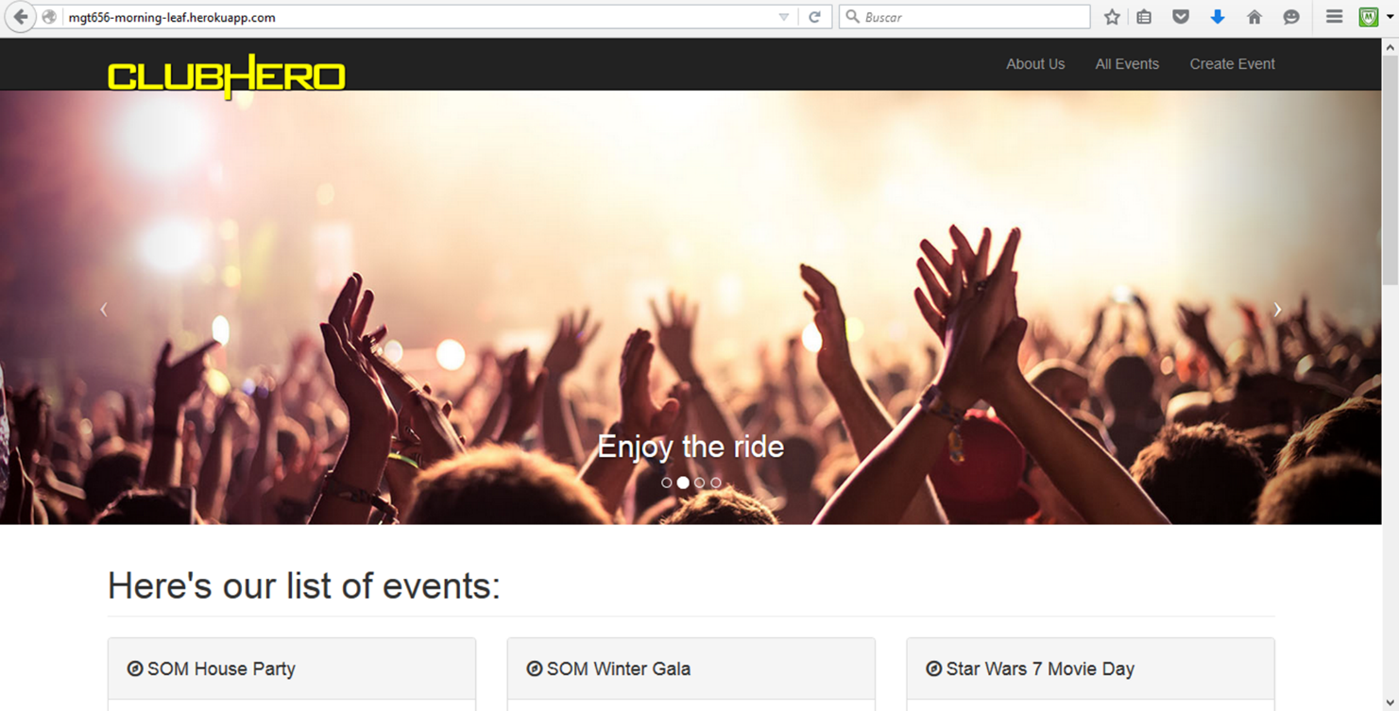

***Figure 11***

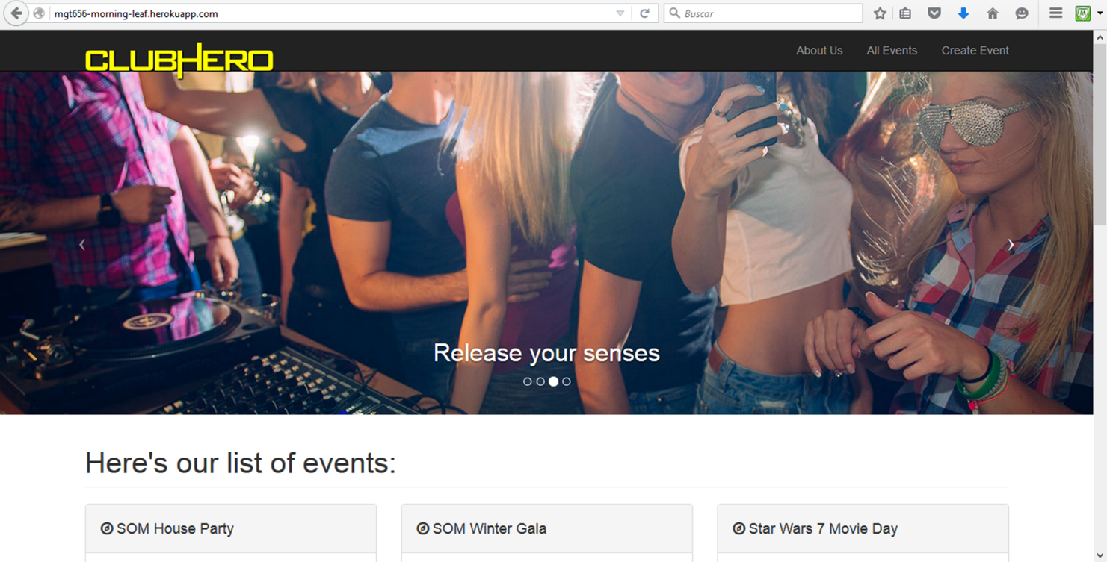

***Figure 12***

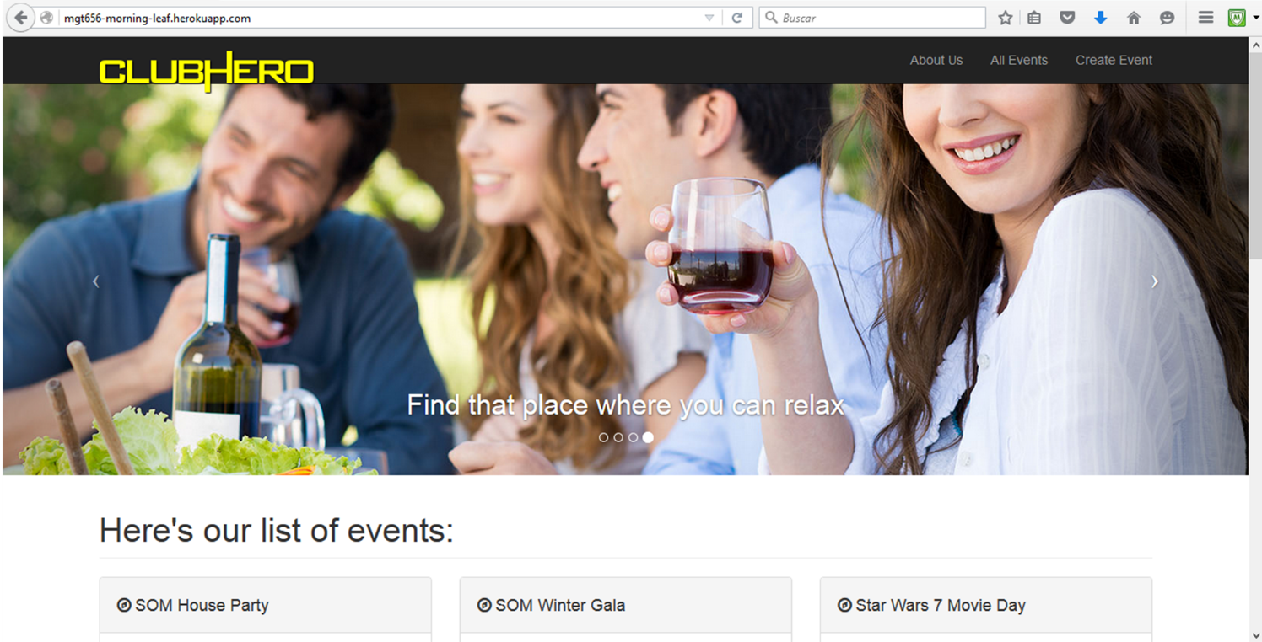

***Figure 13***

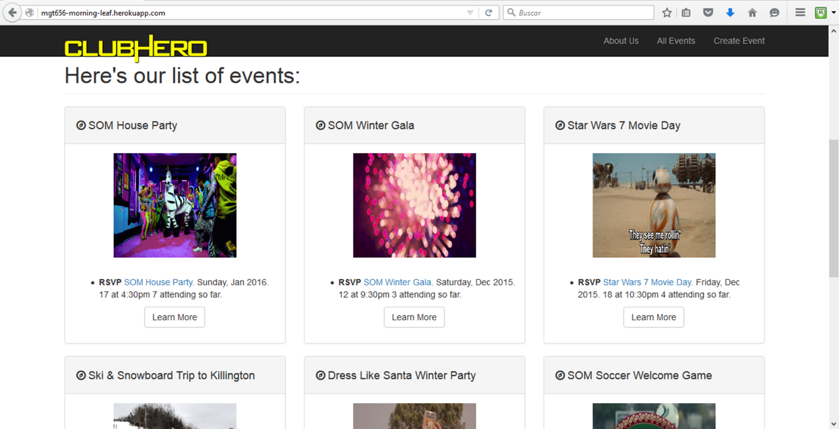

***Figure 14***

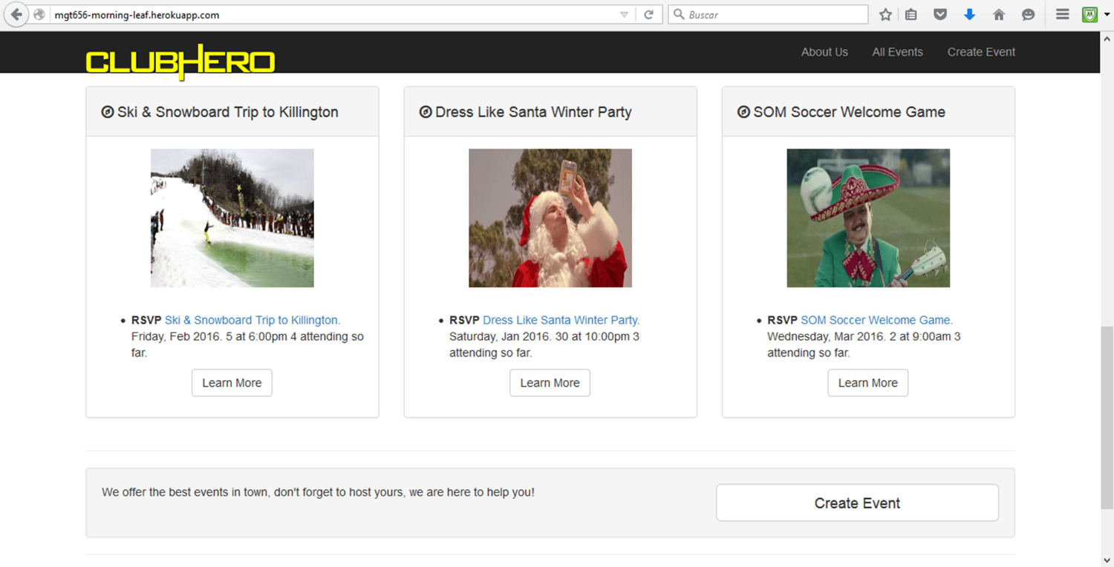

***Figure 15***

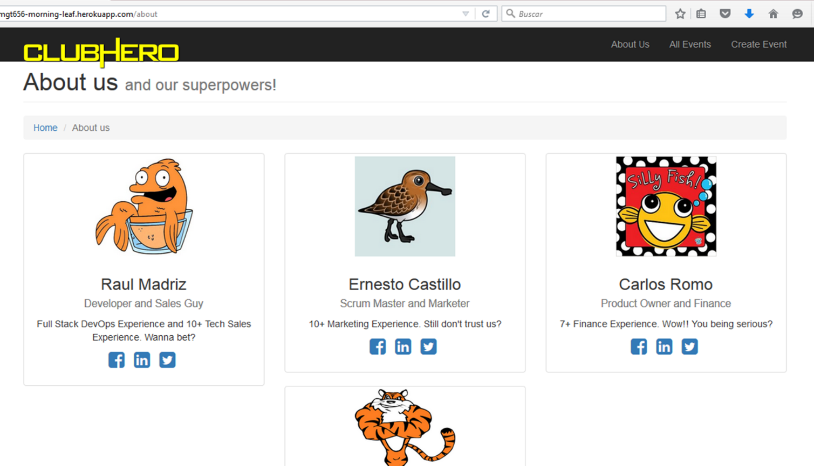

***Figure 16***

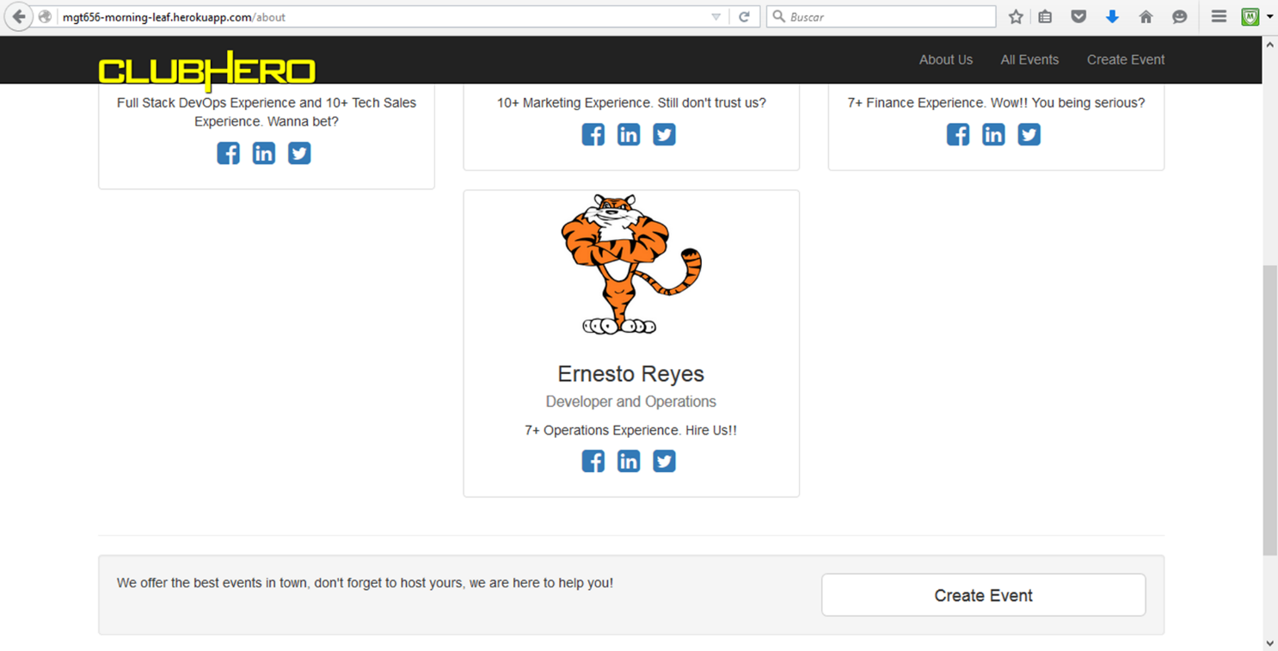

***Figure 17***

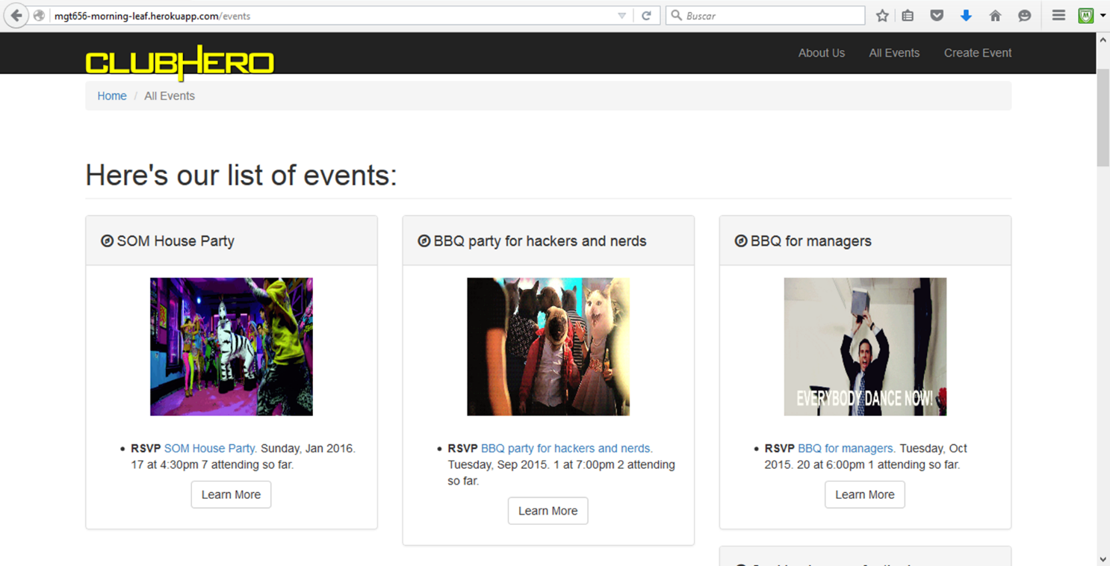

***Figure 18***

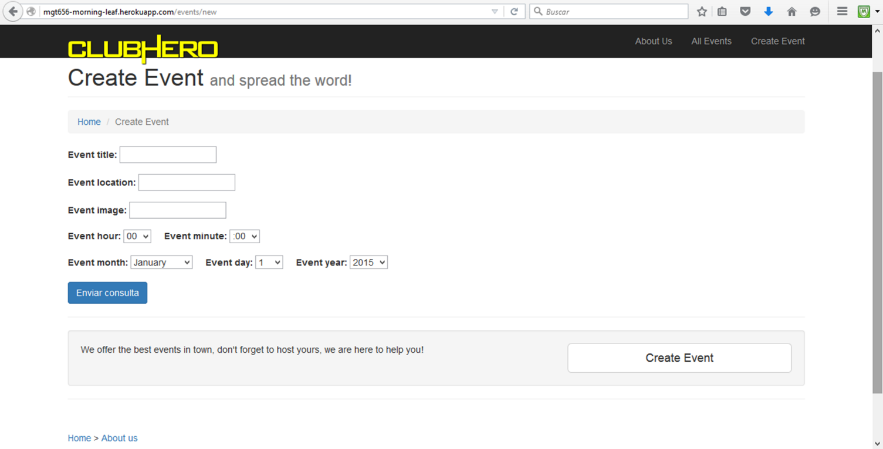

***Figure 19***

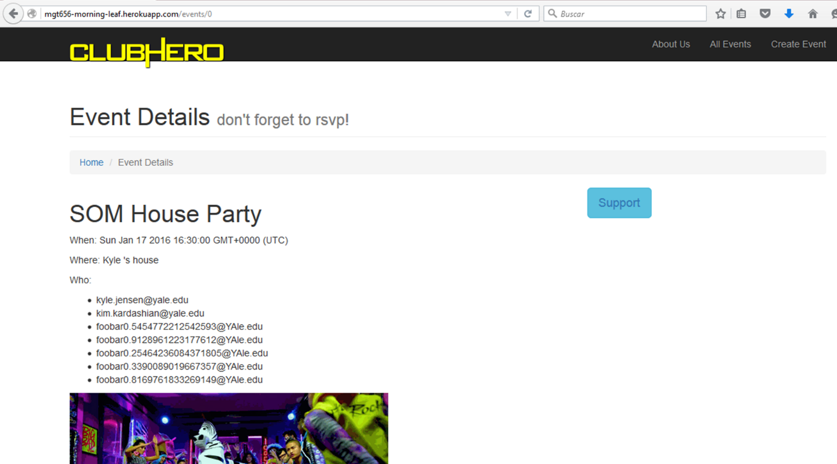

***Figure 20***

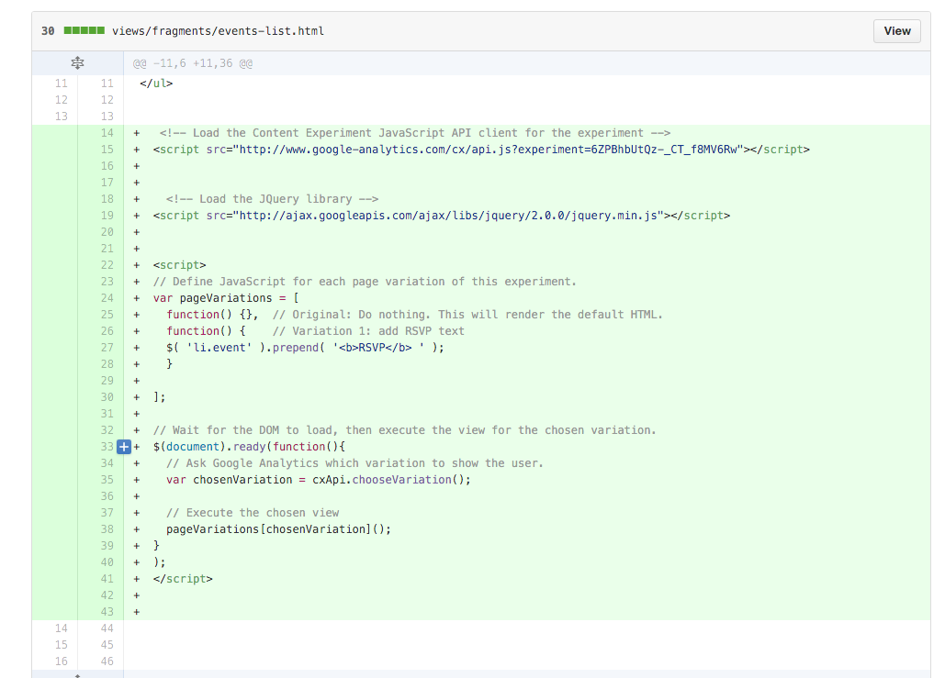

***Figure 21***

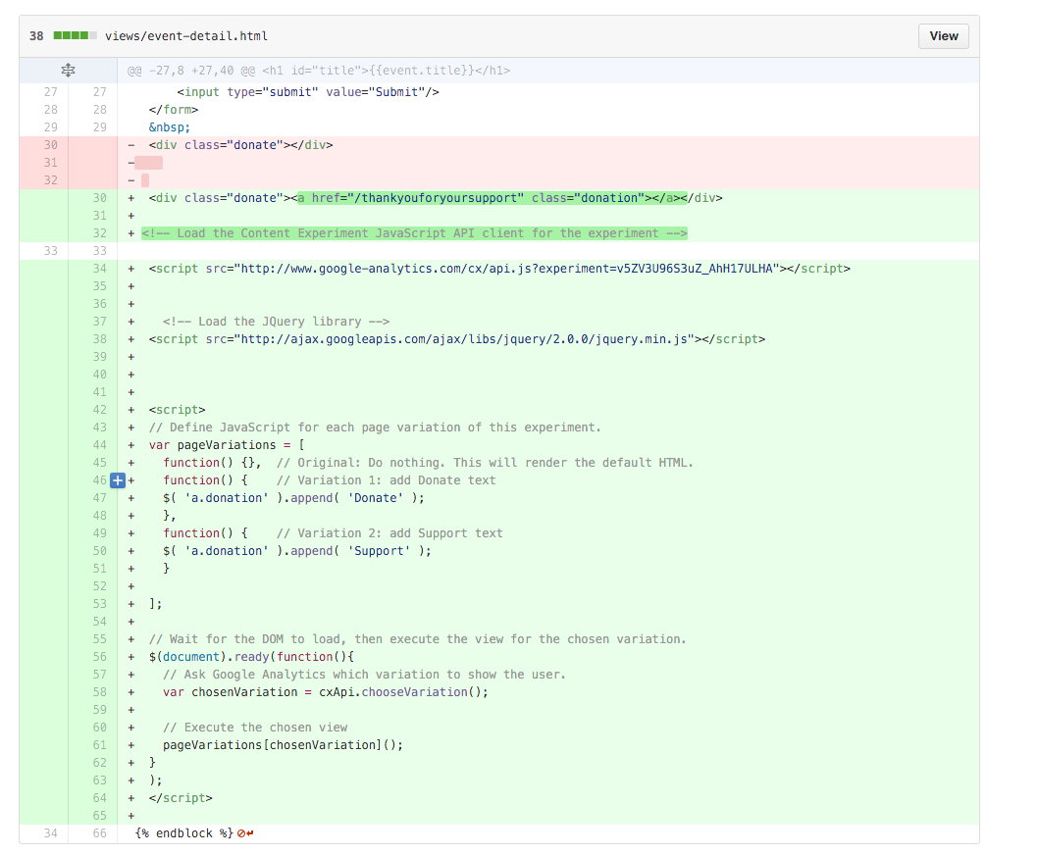

***Figure 22***

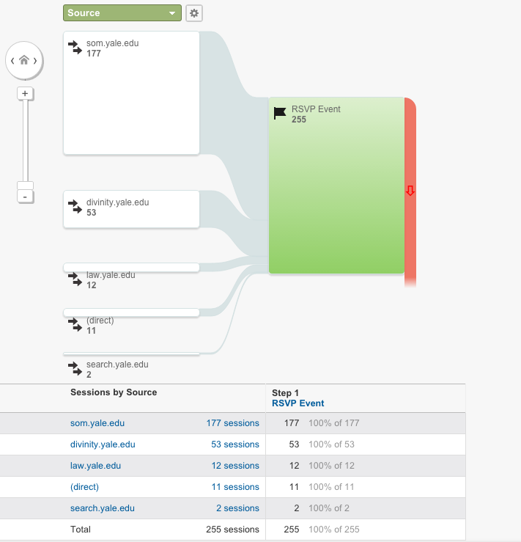

***Figure 23***

We hope that with this information you have a better knowledge of the application that the team Morning-Leaf developed and the importance of the team on delivering high quality on the product. We would like to add that to run the tests we configured the mocha to run with a timeout of 8000ms (8 seconds). In the following figures we show this configuration.

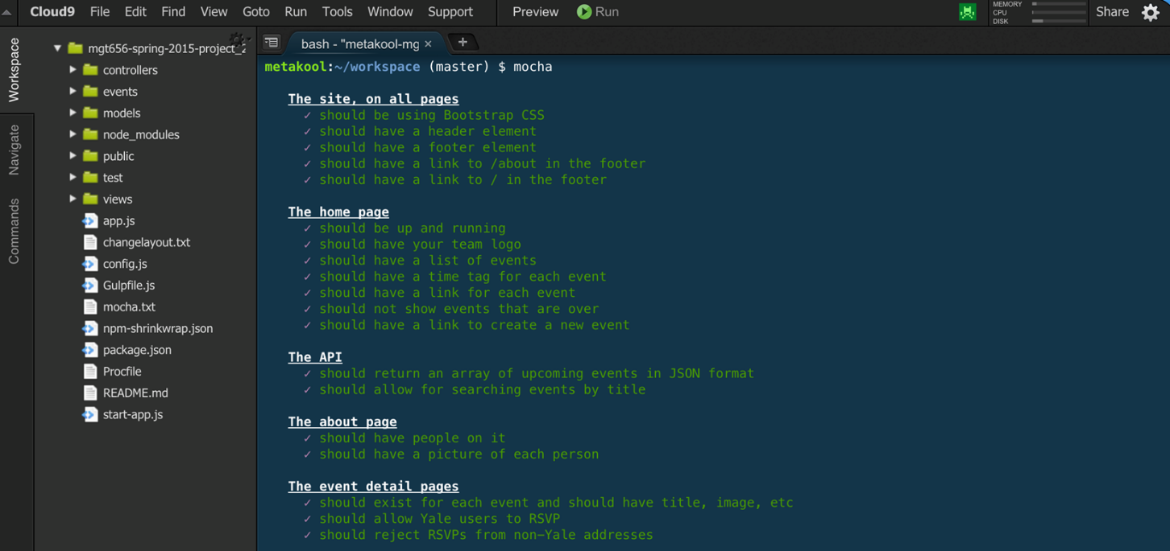

***Figure 24***

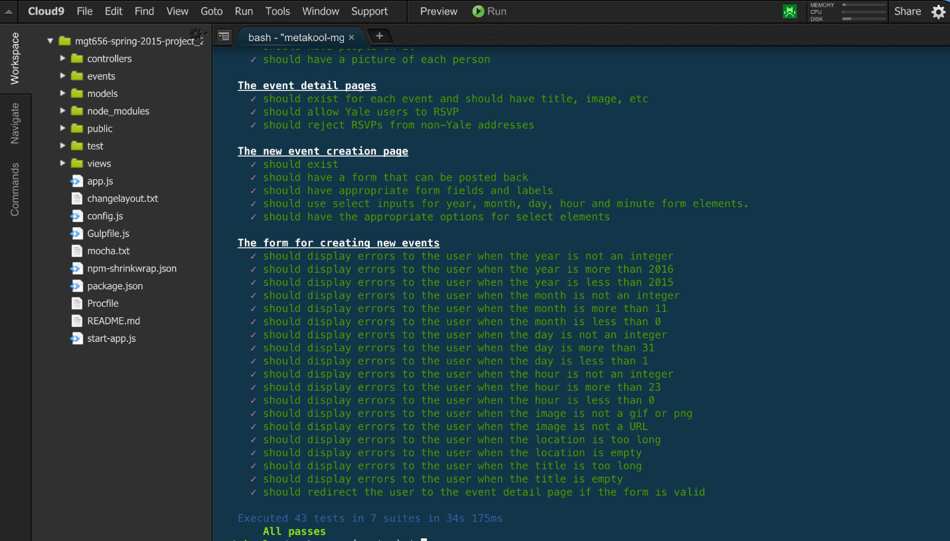

***Figure 25***